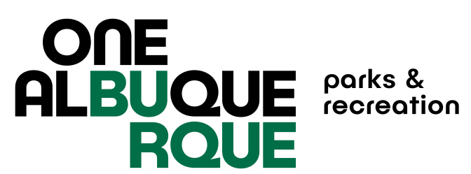

City of Albuquerque Parks and Recreation
2024 FALL Softball
4 Week Double Header League
Registration Check List
Fall Registration Dates 7/8/24-8/2/24

Note: Each item listed below must be completed in order for your team to participate: Teams who do not turn in the required paperwork will not receive a schedule and will have to forfeit games. Paperwork must be turned in to the office – no email, fax or other electronic paperwork accepted.

REGISTRATION FEES ARE NON-REFUNDABLE ONCE REGISTRATION CLOSES.

Complete and turn in TEAM REGISTRATION FORM
to the Jerry Cline Recreation and Tennis Center between July 8 -
August 2, 2024. Last registration taken at 5pm on 8/2/24.

Pay the $495.00 TEAM FEE at the Jerry Cline Tennis Center
at the time you turn in your team registration form. Forms of payment accepted are: cash, check, credit card. Checks payable to City of Albuquerque.

Pay the $50.00 USSSA sanction fee at http://www.rctipif.org. Please go through this website ONLY as all other website registrations are not valid for the City of Albuquerque. This fee is required once per year and covers spring, summer, fall seasons.

Turn in original completed team roster with all signatures and ID numbers filled in, USSSA waiver of liability form, Code of Conduct Form signed by individual participants, and proof of USSSA Sanction Fee for 2024 by September 5, 2024 to the Jerry Cline Recreation and Tennis Center. All players must sign a new USSSA waiver and CABQ Code of Conduct each season.

Managers must attend the rules and conduct meeting at Jerry Cline on September 4th or 5th, 2024 at 6:00PM.

